**Tugas 10 Praktikum**

Pengembangan Perangkat Lunak





**Pemograman Backend**

Nama : Faiz Haidar

NIM : 22255601008

**PeTIK II Jombang YBM PLN Tahun Akademik 2022/2023**

**Plosogeneng, Kec. Jombang, Kabupaten Jombang, Jawa Timur**

1. **Membuat migration pengarang dengan penulisan berikut**



Isi pada file migration pengarang:

<?php

use Illuminate\Database\Migrations\Migration;

use Illuminate\Database\Schema\Blueprint;

use Illuminate\Support\Facades\Schema;

return new *class* *extends* *Migration*

{

*/\*\**

*\* Run the migrations.*

*\**

*\* @return void*

*\*/*

*public* *function* up()

    {

        Schema::create('pengarang', *function* (Blueprint $table) {

            $table->increments('id');

            $table->string('nama', 50);

            $table->string('email')->unique();

            $table->string('hp');

            $table->timestamps();

        });

    }

*/\*\**

*\* Reverse the migrations.*

*\**

*\* @return void*

*\*/*

*public* *function* down()

    {

        Schema::dropIfExists('pengarang');

    }

};

1. **Membuat migration penerbit dengan penulisan berikut**



Isi pada file migration penerbit

<?php

use Illuminate\Database\Migrations\Migration;

use Illuminate\Database\Schema\Blueprint;

use Illuminate\Support\Facades\Schema;

return new *class* *extends* *Migration*

{

*/\*\**

*\* Run the migrations.*

*\**

*\* @return void*

*\*/*

*public* *function* up()

    {

        Schema::create('penerbit', *function* (Blueprint $table) {

            $table->increments('id');

            $table->string('nama', 50);

            $table->text('alamat');

            $table->string('email')->unique();

            $table->string('website');

            $table->string('telepon');

            $table->string('cp');

            $table->timestamps();

        });

    }

*/\*\**

*\* Reverse the migrations.*

*\**

*\* @return void*

*\*/*

*public* *function* down()

    {

        Schema::dropIfExists('penerbit');

    }

};

1. **Membuat migration kategori dengan penulisan berikut**



isi pada file migration kategori

<?php

use Illuminate\Database\Migrations\Migration;

use Illuminate\Database\Schema\Blueprint;

use Illuminate\Support\Facades\Schema;

return new *class* *extends* *Migration*

{

*/\*\**

*\* Run the migrations.*

*\**

*\* @return void*

*\*/*

*public* *function* up()

    {

        Schema::create('kategori', *function* (Blueprint $table) {

            $table->increments('id');

            $table->string('nama', 50);

        });

    }

*/\*\**

*\* Reverse the migrations.*

*\**

*\* @return void*

*\*/*

*public* *function* down()

    {

        Schema::dropIfExists('kategori');

    }

};

1. **Membuat migration buku dengan penulisan berikut**



Isi file migration buku

<?php

use Illuminate\Database\Migrations\Migration;

use Illuminate\Database\Schema\Blueprint;

use Illuminate\Support\Facades\Schema;

return new *class* *extends* *Migration*

{

*/\*\**

*\* Run the migrations.*

*\**

*\* @return void*

*\*/*

*public* *function* up()

    {

        Schema::create('buku', *function* (Blueprint $table) {

            $table->increments('id');

            $table->string('isbn');

            $table->string('judul');

            $table->year('tahun_cetak');

            $table->integer('stok');

            $table->integer('idpengarang')->unique();

            $table->integer('idpenerbit')->unique();

            $table->integer('idkategori')->unique();

            $table->timestamps();

        });

    }

*/\*\**

*\* Reverse the migrations.*

*\**

*\* @return void*

*\*/*

*public* *function* down()

    {

        Schema::dropIfExists('buku');

    }

};

1. Membuat Seeder Buku



1. Membuat Seeder Pengarang



1. Membuat Seeder Penerbit



1. Membuat Seeder Kategori



1. Screenshoot CRUD Pengarang

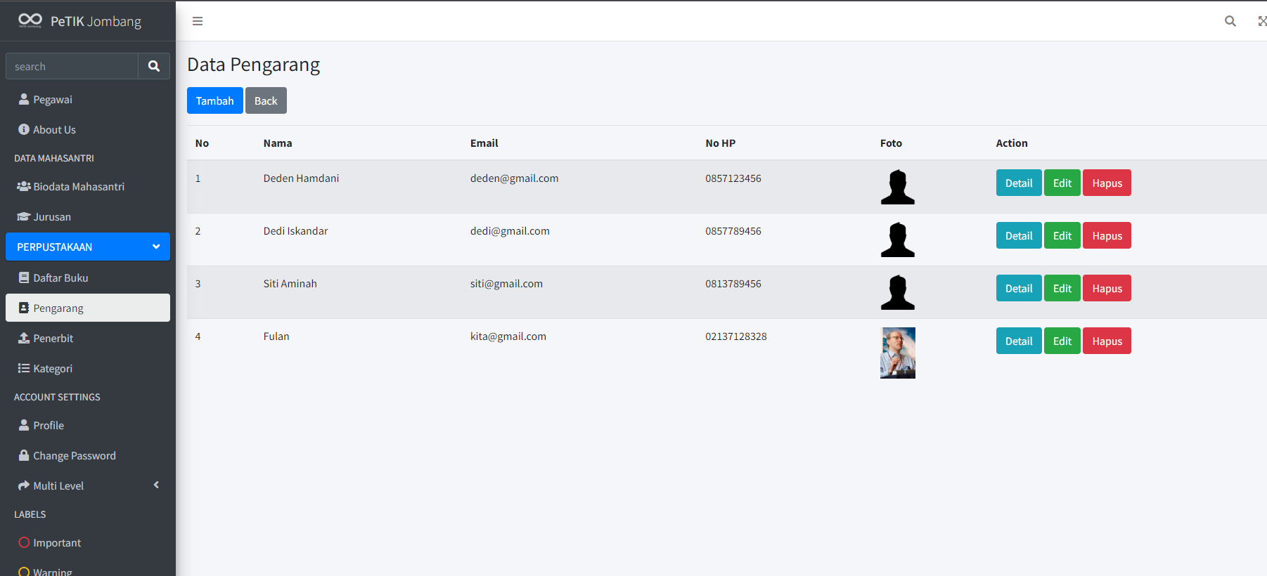

1. Screenshoot CRUD Penerbit

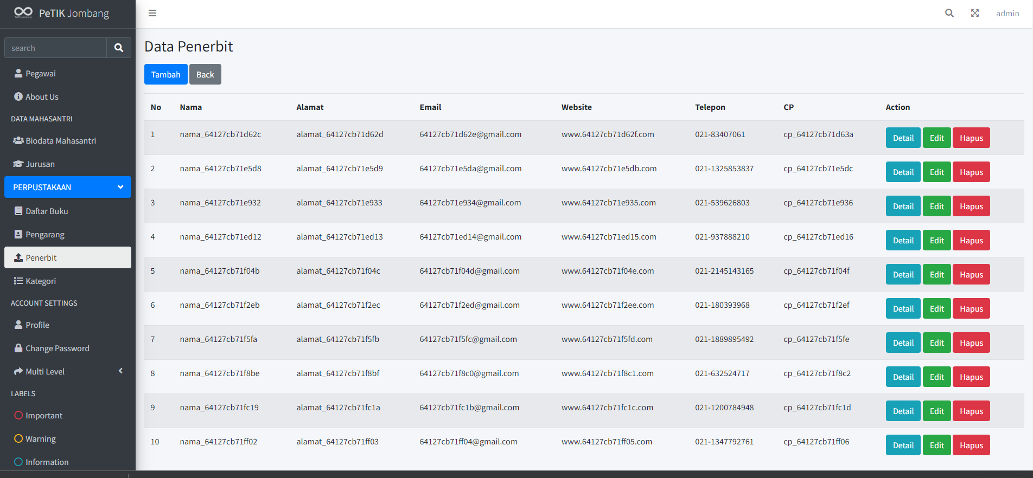

1. SS CRUD Kategori

